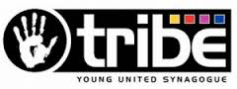
Tribe, the Young United Synagogue arm, was created to inspire young people to be proud of their Jewish identity and to become active members or our communities. Tribe has contributed significantly to supporting youth activities in Muswell Hill and is an important channel for our efforts to create a vibrant context for young people in our own and the wider Jewish community.

