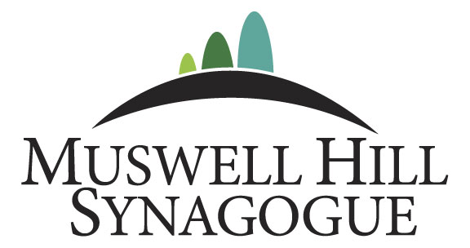

IS DELIGHTED TO INVITE YOU TO OUR COMMUNITY LUNCH



Where we are pleased to be honouring our Chatanim, Rabbi Michael Rosenfeld and Andrew Shindler, on Simchat Torah - Wednesday, 15 October, starting at around 12.30pm.
Pre-booking is essential – click here to make your bookings and a suggested voluntary contribution is requested as follows:
Member – Adult - £15 per person Member – Child - £10 per person
Non-Member – Adult - £18 per person Non-Member – Child - £12 per person

